Beginner Cello Exercise

Before you try playing this music check through these helpful hints!
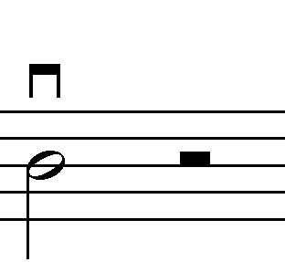

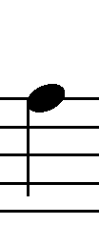
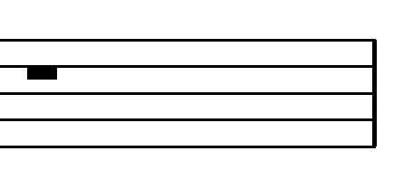
D minim and minim rest Down bow A crotchet Rest
2 beats each Start at heel 1 beat 4 beats

Underneath your notes there are volume (dynamics) instructions

f - forte. Play loudly, use all your bow and press firmly!
p - piano. Play quietly, use less bow and press lightly!

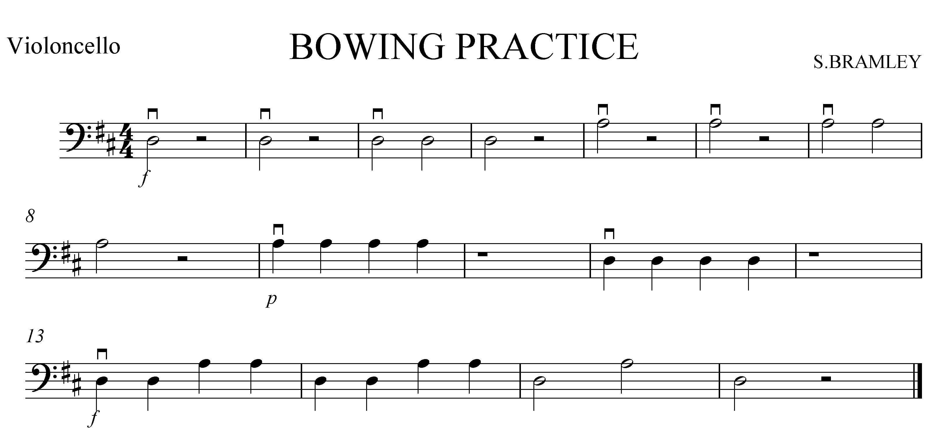
Can you record yourself playing this?

Could you improve your performance?

