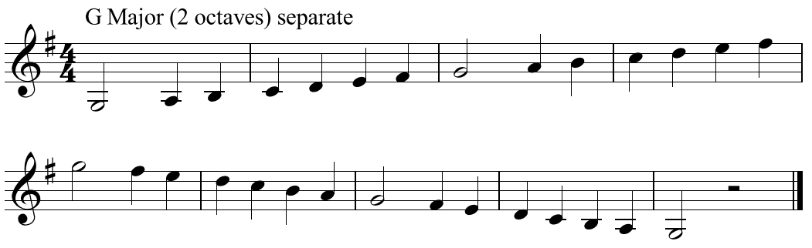**G Major Scale (two octaves)**

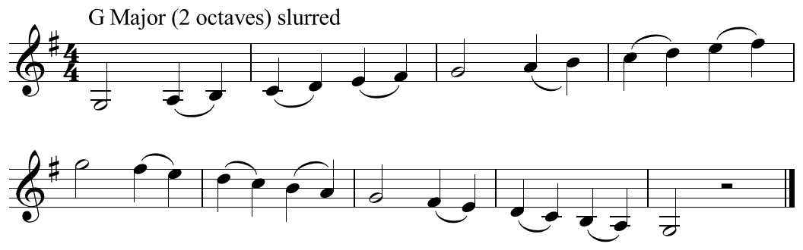

Use all the numbers to play the scale.

Use the red numbers to play the arpeggio

