**F Major Scale (one octave)**

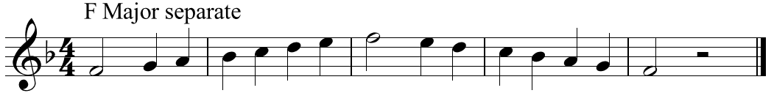

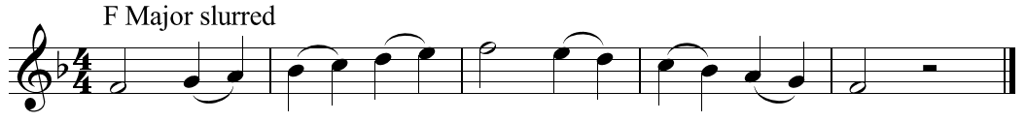

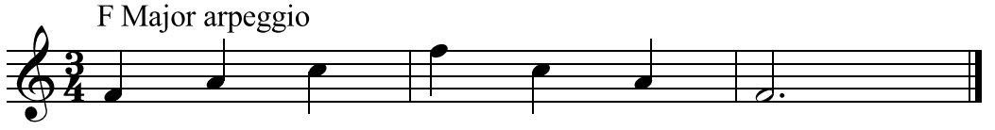



Use all the numbers to play the scale.

Use the red numbers to play the arpeggio